Monthly Report
January 2014
- Participating in Annual Meeting for 2013 at PHD
PHD hold the annual meeting for the end of 2013 which chair by Provincial Deputy Governor and participated by both Local and International Organization, POEYS Officer and Health Officer from PHD, Referral Hospital, Operational District and Health Center.
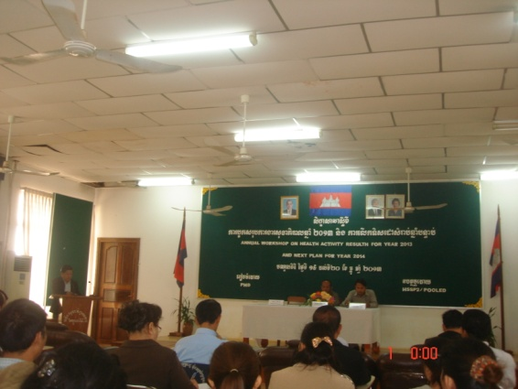

- Schedule and outline of activities

Date | am/pm | Activities | Other
07 Jan  (Tue) | pm | ○Move to MDK from PP
08 Jan  (Wed) | am | ○School education  ,Pou Chrey PS, Pou Cheychang PS  ○HC Education  Keo Seima HC(Mr. Theara | ○HC Education  Ou Am HC (Mr. Theara & Lay)
 | Pm | ○School monitoring  Senmonorom PS
09 Jan  (Thu) | Am | ○School monitoring  Poutrom Thmey PS (7:15)  ○ Participate Annual Meeting  PHD Office (1) | Annual Meeting 2013 & Action Plan 2014. It last for 2 full days hosted by PHD
 | Pm | ○ Participate Annual Meeting  PHD Office (2)
10 Jan  (Fri) | Am | ○School education  Krong Tes PS  ○HC Education  Krong Tes HC
 | Pm | ○ Participate Annual Meeting  PHD Office (4)
11 Jan  (Sat) | Am | ○School education  De A PS & Pou Til PS (Lay)  Pou Rapet PS (Theara)
 | Pm | ○Move to PP from MDK

- School Project

- School Education and Training
No | School Name | Date | Number of Teachers Participated | Number of TB & TP Provided | Number of Class | Brushing Day | Oral Health Education Day
1 | Pou Chrey PS | 08th- Jan | 5 | 110 | 3 | Everyday | Thu/1st Week
2 | Pou Cheychang PS | 08th- Jan | 3 | 163 | 6 | Everyday | Thu/3rd Week
3 | Dei Ey PS | 11th- Jan | 6 | 108 | 5 | Mon & Thu | Thu/2nd Week
4 | Pou Til PS | 11th- Jan | 3 | 76 | 3 | Everyday | Thu/2nd Week
5 | Pou Rapet PS | 11th- Jan | 3 | 188 | 6 | Mon & Fri | Thu/2nd Week
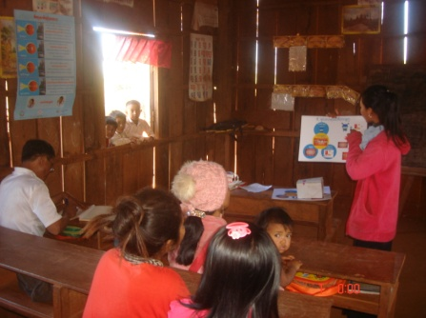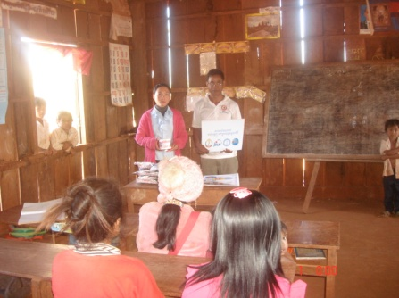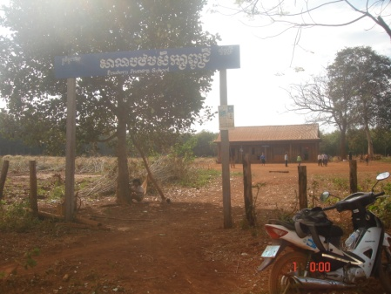
Fig.3 (Pou Chrey PS )
Fig.2 (Received TB, TP, Flipchart &
DentalModel By Teachers at Pou Chrey PS )
Fig.1 (Oral Health Education By Teachers
at Pou Chrey PS )

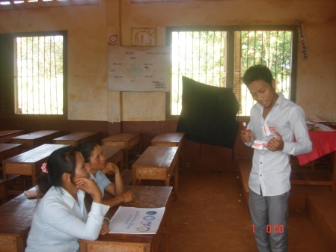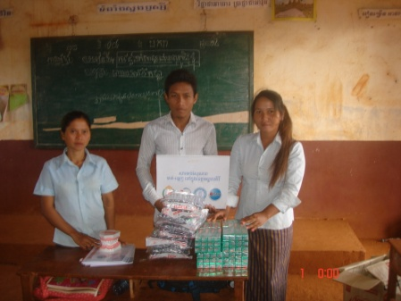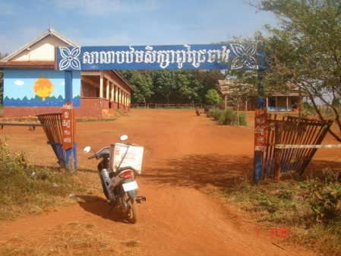
Fig0.6 (Pou Chrey Chang PS )
Fig.05 (Received TB, TP, Flipchart &
DentalModel By Teachers at Pou Chrey Chang PS )
Fig.04 (Oral Health Education By Teachers
at Pou Chrey Chang PS )

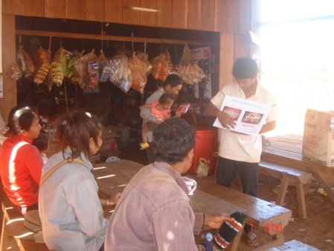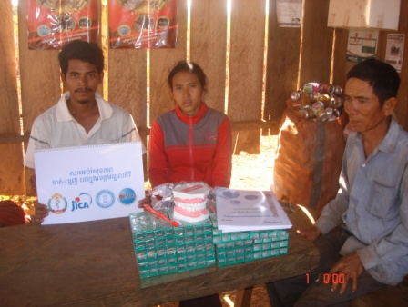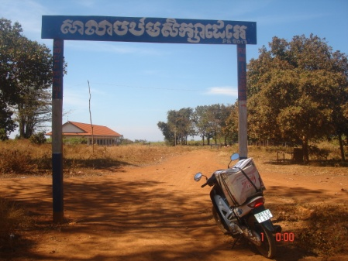
Fig.07 (Oral Health Education By Teachers
at Dei Ei PS )
Fig.09 (Dei Ei PS )
Fig.08 (Received TB, TP, Flipchart & DentalModel By Teachers at Dei Ei PS )
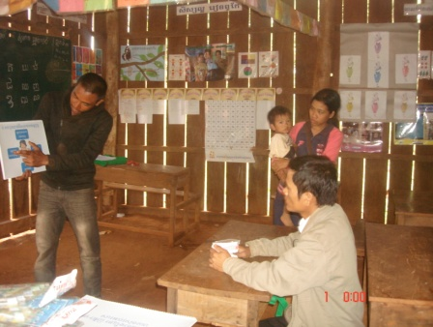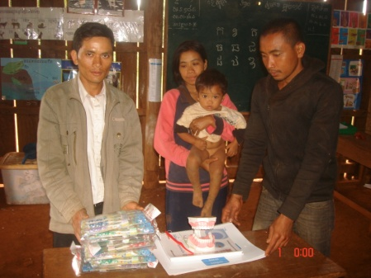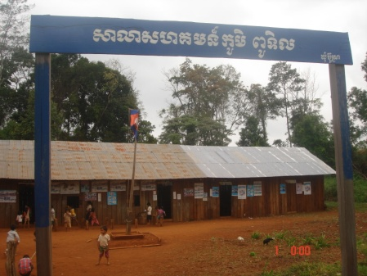
Fig.12 (Oral Health Education By Teachers
at Pou Til PS )
Fig.11 (Oral Health Education By Teachers
at Pou Til PS )
Fig.10 (Oral Health Education By Teachers
at Pou Til PS )
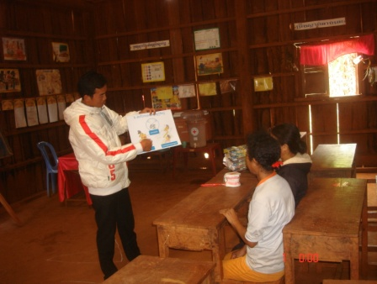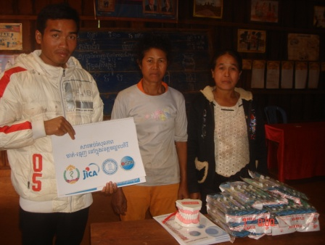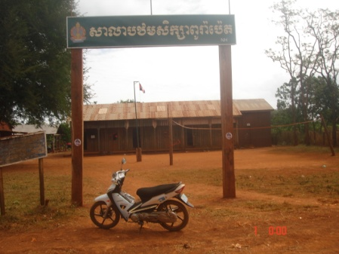
Fig.13 (Oral Health Education By Teachers
at Pou Rapet PS )
Fig.15 (Oral Health Education By Teachers
at Pou Rapet PS )
Fig.14 (Oral Health Education By Teachers
at Pou Rapet PS )

- School Monitoring
No | School Name | Date | Number of students Participated | Number of Oral Health Chapter Provided | Grade | Brushing Day | Oral Health Education Day
1 | Senmonorom PS | 08th- Dec | 27 | 1(Ch: & 9) | 5 | Everyday | Thu/3rd Week
2 | PS Poutrom Thmey PS | 09th - Jan | 47 | 1(Ch:10) | 3&4 | Everyday | Thu/3rd Week
3 | Poutrom III | 10th - Jan | No Class | No Class | No Class | No Class | No Class

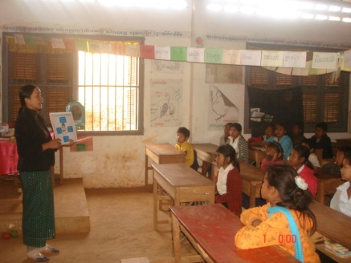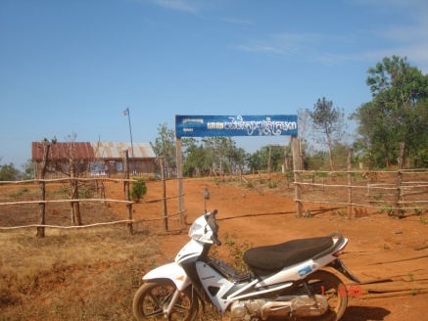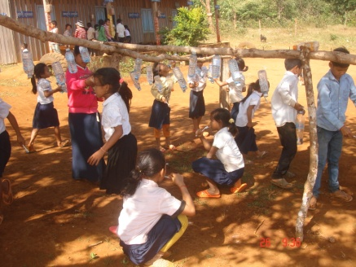
Fig.17 (Poutrom 3 PS Closed due to students asked for 3 days off to help family to harvest )
Fig.18 (Brushing & washing hand by Student at Poutrom Thmey PS )
Fig.16 (Oral Health Education by Teacheer at Senmonorom PS )

Due to every school’s schedule of oral health education, we have followed up their activities basing on their schedule which most of the school select Thursday to implement Oral Health Education class, so that just only brushing activities we could motion if it is not fall on Thursdays!
Note! This school used to be provided soap and how to wash hand by Japanese Businessman
(Mr. Pony & Mr. Shida).
- Community Project
- Health Center Education and Training
No | Health Center Name | Date | Number of HC Staff Participated | Number of TB & TP Provided | Number of Flipchart Provided | Number of Dental Model Provided
1 | Ou Am HC | 08th- Jan |  | 100 | 2 | 1
2 | Keo Seima HC | 08th - Jan |  | 100 | 2 | 1

OISDEC staff provided Oral Health Education by flipchart to HC staff in order to ask them to promote and share the knowledge to their community. Our DCAs have already been known by targeted HC when they came up to HC with identification letter from PHD. DCAs required working at HC a day per week and as for the schedule, HC director could have authority to ask them to change to fit with HC schedule.
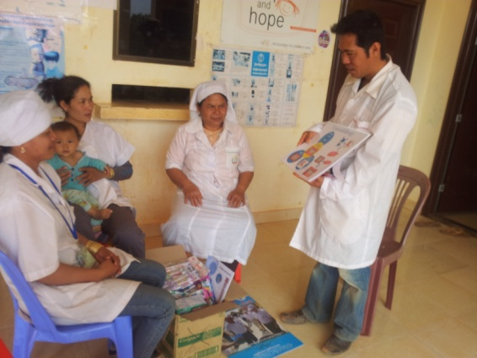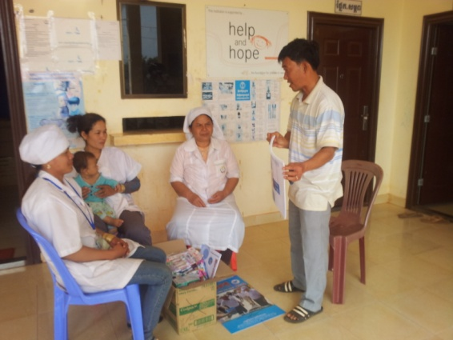
Fig.19 (Oral Health Education by Ou Am HC)
Fig.18 (Oral Health Education to Ou Am HC by Health Promotion Officer)

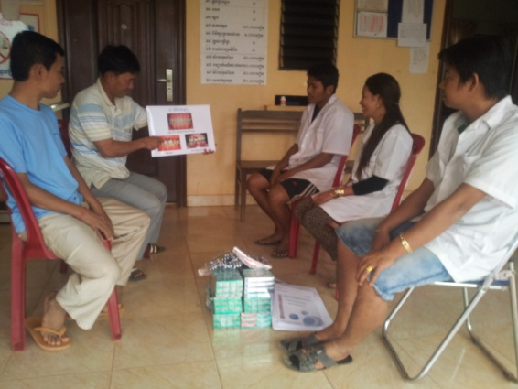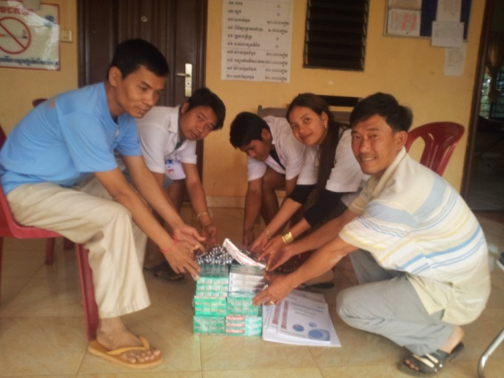
Fig.21 (Received TB & TP, Flipchart and Dental Model by Keo Seima HC)
Fig.20 (Oral Health Education to Keo Seima HC by Health Promotion Officer)

- Other
I have a meeting with Japane Businessman, Mr. Pony, Mr. Shida & Mr. Sasaki in Phnom Penh related to Soap donation to our targeted school in MDK. They would like to buy natural honey from MDK in order to make Soap and import it to Japan. I have talked to them if they would buy it from our DCA, it might useful for DCAs and their company because our DCAs could make small money beside working with us and Japanese side also could get a better price and honey than the one that they could find in the market!
They said that if it is fine for OISDE, they would like to donate some Soap to one more school in MDK in February and to make agreement with our DCAs related to honey selling.
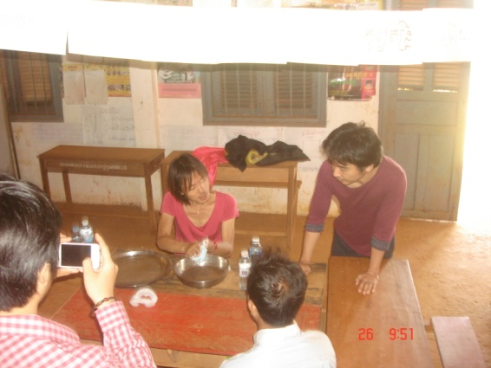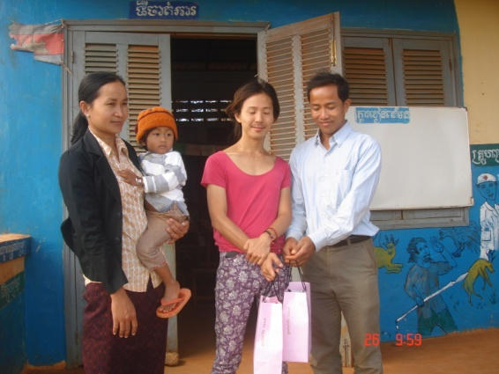
Fig.23 (Mr. Pony & Mr. Shida Show how to do Hand Washing to Teachers)
Fig.24 (Donation Soap to Teachers at Poutrom Thmey PS)

Made By: Mr. Meng Sokhalay
Project Coordinator
Date: 30th January 2014

