Monthly Report
February 2014
Date | am/pm | Contents | Other
11 Feb  (Tue) | am | ○Move to MDK from PP
 | pm | ○Meeting With POEYS  Discuss about one school in Pichreada which difficult to access
12 Feb  (Wed) | am | ○School education  Koma Mekong PS, Ou Play PS  ○HC Education  Koh Nhek HC(Mr. Theara
 | pm | ○School monitoring  Poutrom III
13 Feb  (Thu) | am | ○School education  Lao Romeat PS, Ou Te PS
 | pm | ○ School monitoring  Andong Kroleung PS
14 Feb  (Fri) | am | ○School education  Lam Mes PS & Roval Yong PS
 | pm
15 Feb  (Sat) | am | ○School monitoring  Poutaing PS, Lao Ka PS and  Pou Loung PS
 | pm | ○Move to PP from MDK
- Schedule and outline of activities

- School Project

- School Education and Training
No | School Name | Date | Number of Teachers Participated | Number of TB & TP Provided | Number of Class | Brushing Day | Oral Health Education Day
1 | Koma Mekong PS | 12th- Feb | 3 | 213 | 6 | Mon & Fri | Thu/1st Week
2 | Ou Ro Ploy PS | 12th- Feb | 2 | 126 | 3 | Mon & Fri | Thu/3rd Week
3 | Lao Romeat PS & Ou Te PS | 13th- Feb | Not Accessible(Water size still hug)  Teachers in booth school will come up to Sre Ampom in next month!
4 | PS Lam Mes PS | 14th- Feb | 2 | 54 | 3 | Everyday | Thu/2nd Week
5 | Roval Yong PS | 14th- Feb | Not Accessible (Close to Khmer Vietnam Border)

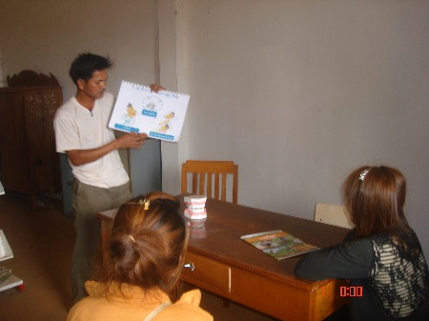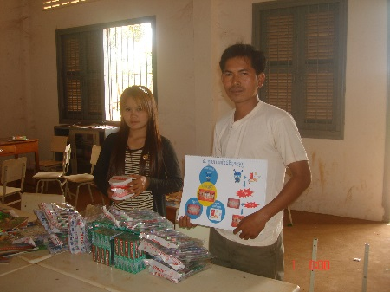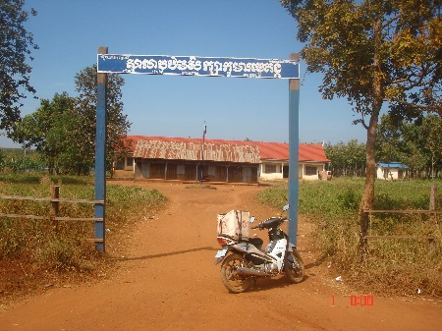
Fig.3 (Koma Mekong PS )
Fig.2 (Received TB, TP, Flipchart &
DentalModel By Teachers at Koma Mekong PS )
Fig.1 (Oral Health Education By Teachers
at Koma Mekong PS )

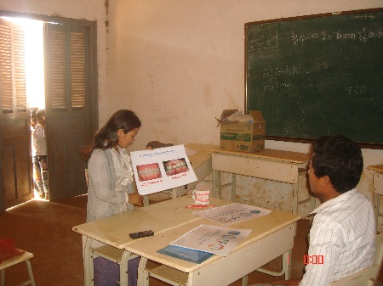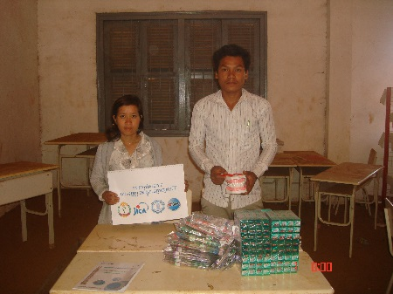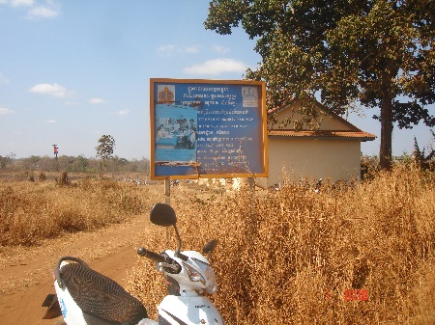
Fig.04 (Oral Health Education By Teachers
at Ou Ro Poy PS )
Fig0.6 (Ou Ro Poy PS without main Gate )
Fig.05 (Received TB, TP, Flipchart &
DentalModel By Teachers at Ou Ro Poy PS )

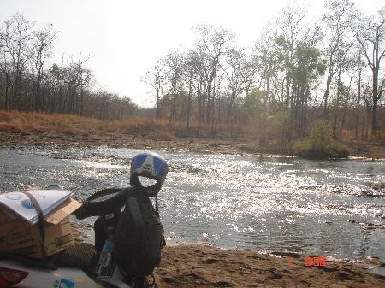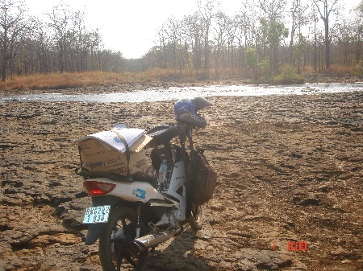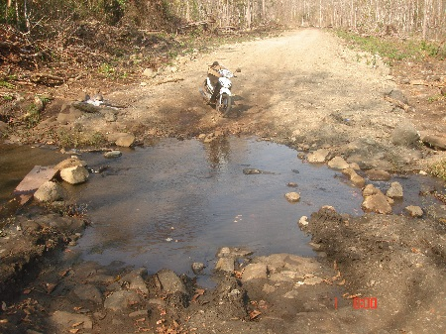
Fig.07 (Road Condition to Lao Romeat PS that impossible for us to across the water in this month )
Fig.09 (This water is possible to across to
Lao Romeat PS )
Fig.08 (Water is still big within
this month PS )

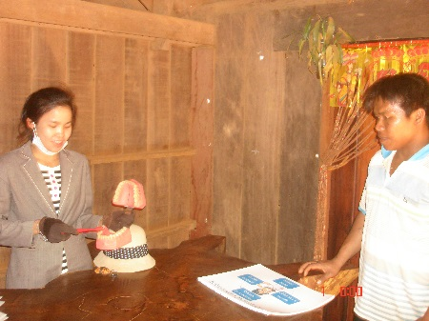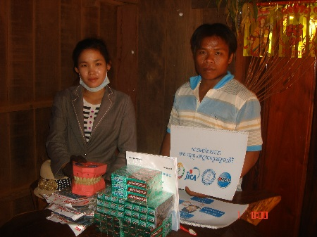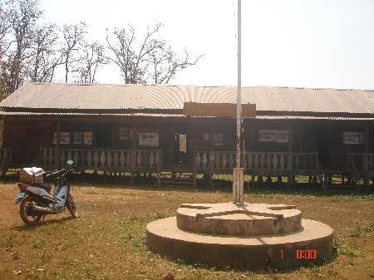
Fig.10 (Oral Health Education By Teachers
at Lam Mes PS )
Fig.12 (Oral Health Education By Teachers
at Lam Mes PS )
Fig.11 (Oral Health Education By Teachers
at Lam Mes PS )

- School Monitoring
No | School Name | Date | Number of students Participated | Number of Oral Health Chapter Provided | Grade | Brushing Day | Oral Health Education Day
1 | Poutrom III PS | 12th- Feb | 16 | 10 & 10 | 5 | Mon & Fri | Thu/3rd Week
2 | Angdong Krorleung PS | 13th- Feb | 13 | 1 & 2 | 5 & 6 | Mon & Fri | Thu/2nd Week
3 | Poutaing PS | 15th- Feb | 22 | 1 & 2 | 5 & 6 | Everyday | Thu/1st Week
4 | Lao Ka PS | 15th- Feb | 43 | 10 | 3 & 4 | Everyday | Thu/1st Week
5 | Pou Loung PS | 15th- Feb | 51 | 10 | 1 & 3 | Everyday | Thu/1st Week

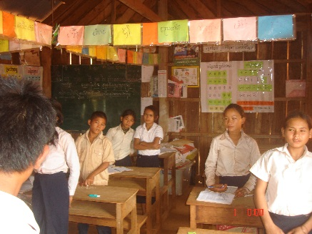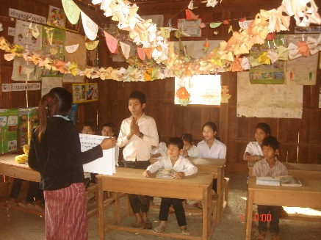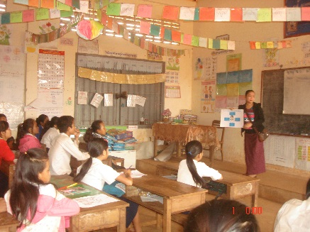
Fig.13 (Oral Health Education by Teacheer at Poutrom III PS )
Fig.14 (Oral Health Education by Teacheer at Andong Kroleung PS )
Fig.15 (Oral Health Education by Teacheer at Poutaing PS)

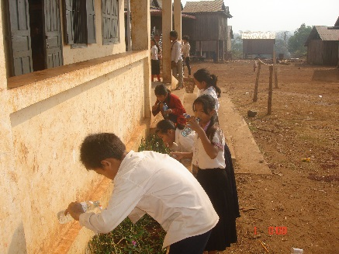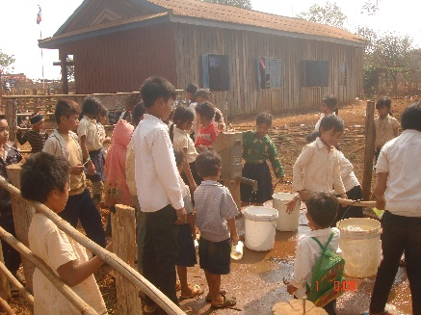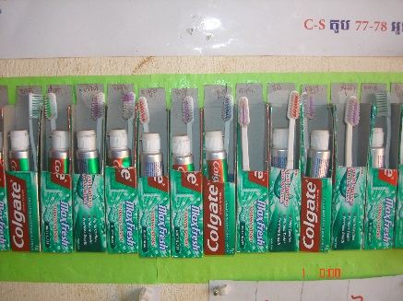
Fig.18 (How to Keep TB & TP at Poutaing PS)
Fig.17 (Brushing Teeth at Pou loung PS)
Fig.16 (Brushing Teeth by Students at Lao Ka PS )

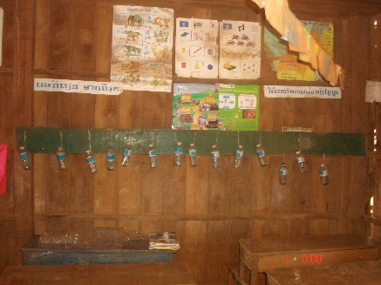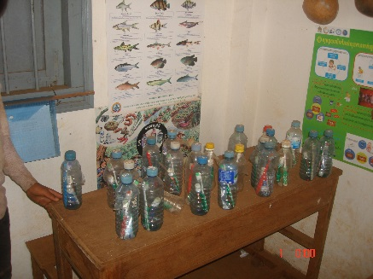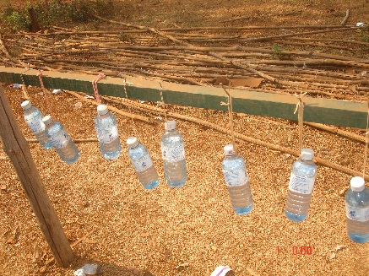
Fig.21 (How to Keep Water for Brushing at Pouloung PS)
Fig.20 (How to Keep TB & TP at Lao Ka PS)
Fig.19 (How to Keep TB & TP Pou Loung PS)

- Community Project
- Health Center Education and Training
No | Health Center Name | Date | Number of HC Staff Participated | Number of TB & TP Provided | Number of Flipchart Provided | Number of Dental Model Provided
1 | Koh Nhek HC | 12th- Feb |  | 100 | 2 | 1

OISDEC staff provided Oral Health Education by flipchart to HC staff in order to ask them to promote and share the knowledge to their community. Our DCAs have already been known by targeted HC when they came up to HC with identification letter from PHD. DCAs required working at HC a day per week and as for the schedule, HC director could have authority to ask them to change to fit with HC schedule.
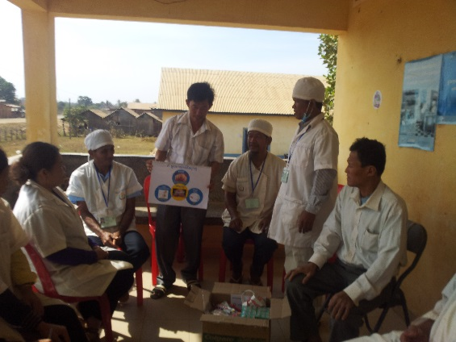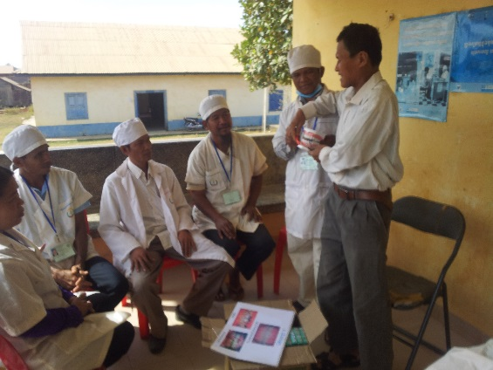
Fig.22 (Oral Health Education to Koh HC by Health Promotion Officer)
Fig.23 (Oral Health Education by Koh Nhek HC)

Made By: Mr. Meng Sokhalay
Project Coordinator
Date: 28th February 2014

