Date | am/pm | Activities | Other
16 Dec (Mon) | am | ○Move to MDK from PP
 | pm | ○Discussion how to implement with Mr. Long Therea
17 Dec (Tue) | am | ○School education  Sre Khleng PS and Leng Chnoung PS
 | pm | ○School monitoring  Monithi Sangkom
18 Dec (Wed) | am | ○School education  Sre Ampom PS, Pou Kreng PS
 | pm | ○School monitoring  Pou Chou PS
19 Dec (Thu) | am | ○School education  Krong Tes PS  ○HC Education  Krong Tes HC
 | pm | ○ Discussion
20 Dec (Fri) | am | ○HC Education  Pichreada HC (Mr. Theara)  ○School monitoring  Poutrom Chas PS  and Andong Krorleung PS (Lay) | Only the last day that we have to be separated to implement!
 | pm | ○Move to PP from MDK
Monthly Report
December 2013
- Introduction
Based on the 2014 action planed made by OISDEC (The Organization of International Support for Dental Education in Cambodia), 16 primary schools in Pichreada Distict as well as 5 Health Centers within Keo Seima District, Pichreada District and Koh Nhek District will be included into intervene schools and health centers.
- Schedule and outline of activities

- School Project

- School Education and Training
No | School Name | Date | Number of Teachers Participated | Number of TB & TP Provided | Number of Class | Brushing Day | Oral Health Education Day
1 | Sre Khleng PS | 17th- Dec | 5 | 710 | 13 | Mon & Fri | Thu/1st Week
2 | Leng Chhoung PS | 17th - Dec | 3 | 253 | 5 | Mon & Fri | Thu/1st Week
3 | Sre Am Pom PS | 18th - Dec | 6 | 183 | 6 | Mon & Fri | Thu/2nd Week
4 | Pou Kreng PS | 18th - Dec | 4 | 80 | 4 | Thu & Sat | Thu/2nd Week
5 | Krang Tes PS | 19th - Dec | 4 | 179 | 6 | Mon & Fri | Thu/2nd Week

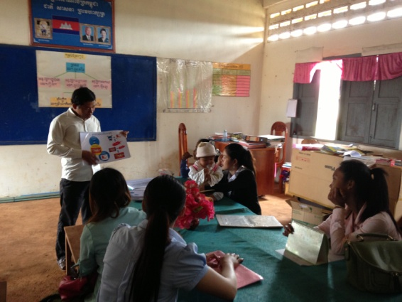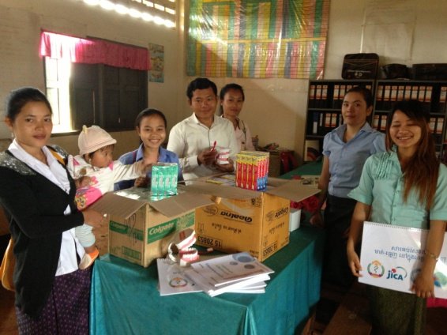
Fig.2 (Received TB, TP, Flipchart & DentalModel By Teachers at Sre Khleng PS )
Fig.1 (Oral Health Education By Teachers at Sre Khleng PS )

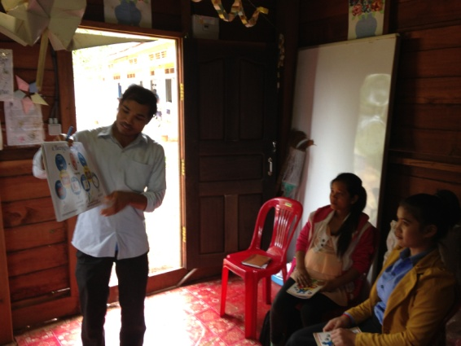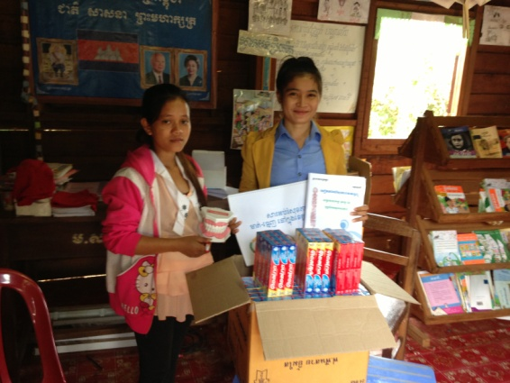
Fig.3 (Oral Health Education By Principal at Leng Choung PS )
Fig.4 (Received TB, TP, Flipchart & DentalModel By Teachers at Leng Choung PS )
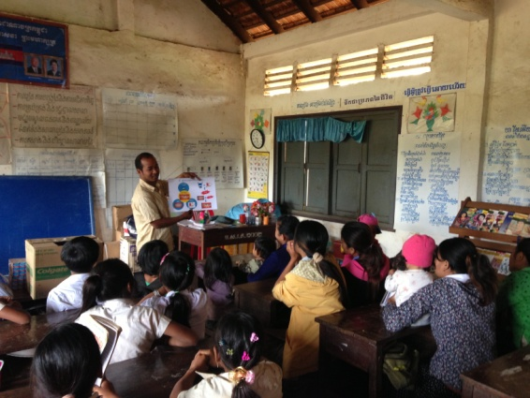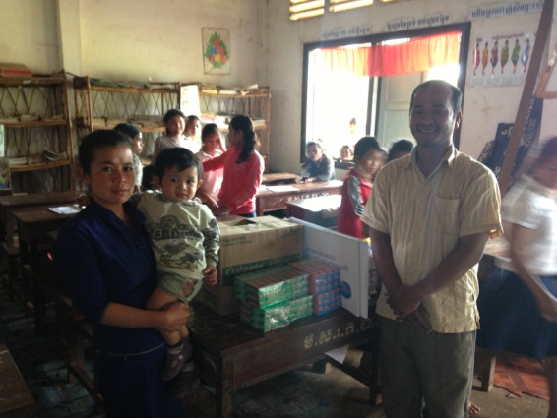
Fig.6 (Received TB, TP, Flipchart & DentalModel By Teachers at Sre Ampom PS )
Fig.5 (Oral Health Education By Vice- Principal at Sre Ampom PS )

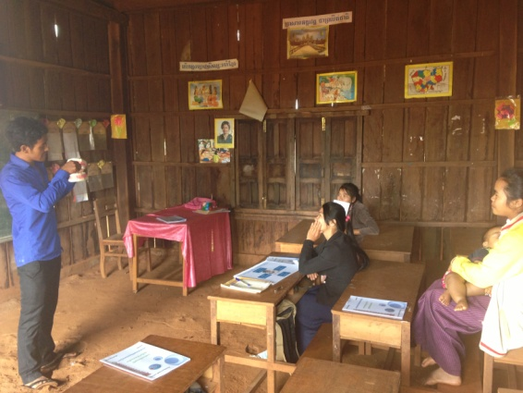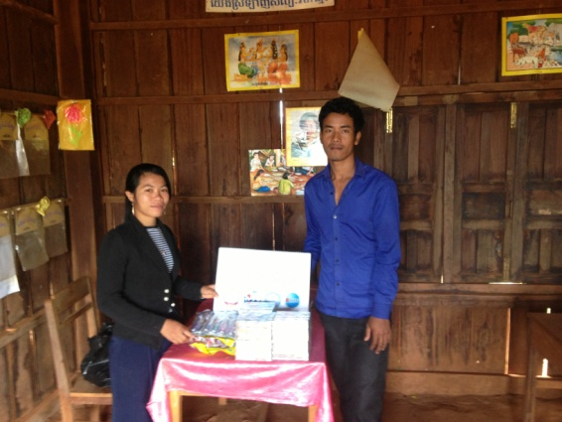
Fig.8 (Received TB, TP, Flipchart & DentalModel By Teachers at Pou Kreng PS )
Fig.7 (Oral Health Education By Teachers at Pou Kreng PS )

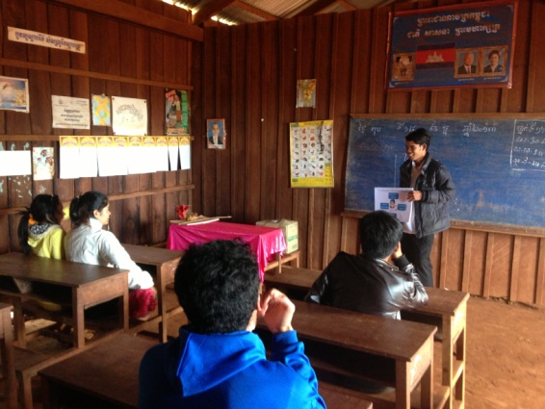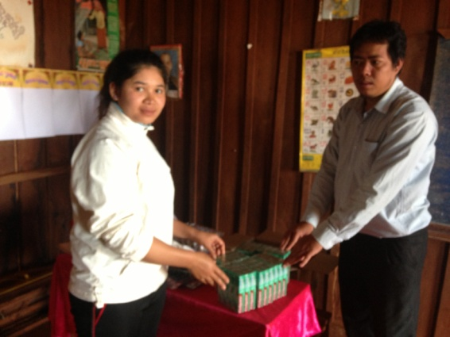
Fig.10 (Received TB, TP, Flipchart & DentalModel By Teachers at Krang Tes PS )
Fig.9 (Oral Health Education By Teachers at Krang Tes PS )

- School Monitoring
No | School Name | Date | Number of students Participated | Number of Oral Health Chapter Provided | Grade | Brushing Day | Oral Health Education Day
1 | Monithi Sangkom PS | 17th- Dec | 38 | 1(Ch:10) | 4 | Everyday | Thu/3rd Week
2 | Poutrom Chas PS | 20th - Dec | 22 | 1(Ch:10) | 3&4 | Everyday | Thu/3rd Week
3 | Andong Kroleung PS | 20th - Dec | 25 | 3 (Ch:5,6&7) | 3 | Mon & Fri | Thu/2nd Week

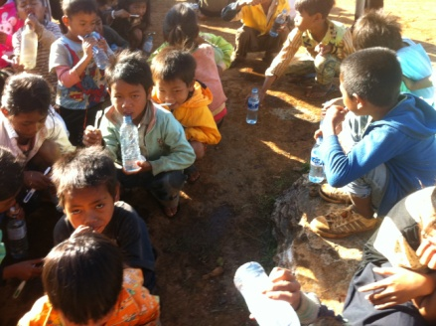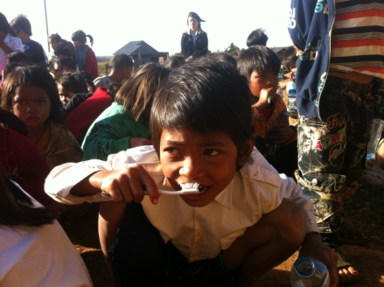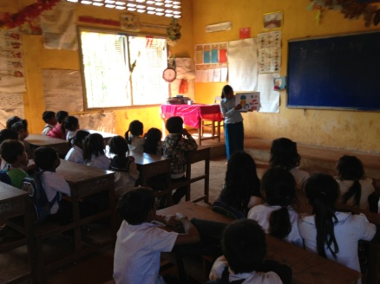
Fig.13 (Oral Health Education by Andong Kroleung Teachers PS )
Fig.12 (Brushing Teeth by Students at Poutrom Chas PS )
Fig.11 (Brushing Teeth by Students at Monithi Sangkom PS )

Due to every school’s schedule of oral health education, we have followed up their activities basing on their schedule which most of the school select Thursday to implement Oral Health Education class, so that just only brushing activities we could motion if it is not fall on Thursdays!
- Community Project
- Health Center Education and Training
No | Health Center Name | Date | Number of HC Staff Participated | Number of TB & TP Provided | Number of Flipchart Provided | Number of Dental Model Provided
1 | Krang Tes HC | 19th- Dec | 3 | 100 | 2 | 1
2 | Pichreada HC | 20th - Dec | 10 | 100 | 2 | 1

Chief of Health Center have discussed with OISDEC staff about how to implement the oral health activities in their health center the fact that it is the first time for them to try to educate oral health in their health center. In addition, to make it easy for them to cooperate with our DCA, they guggest OISDEC to ask Identification Letter from Provincial Health Department and Health Promotion Officer, who worked with OISDEC, has agreed to get approval from PHD by the first week of January.
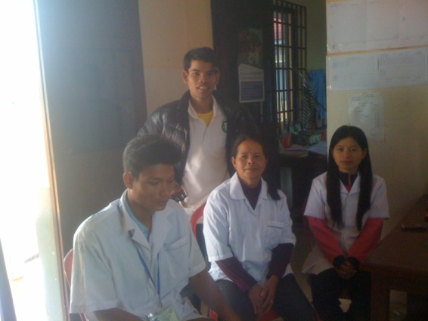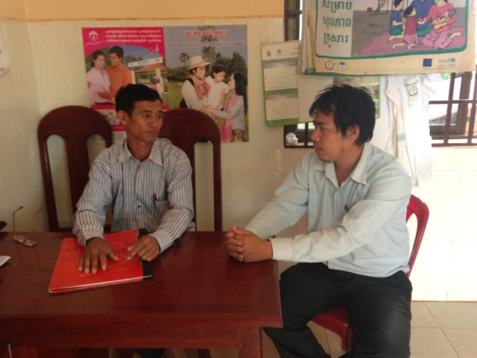
Fig.15 (Dicussion with Chief of Krang Tes HC)
Fig.14 (Oral Health Education to Krang Tes HC by DCA )

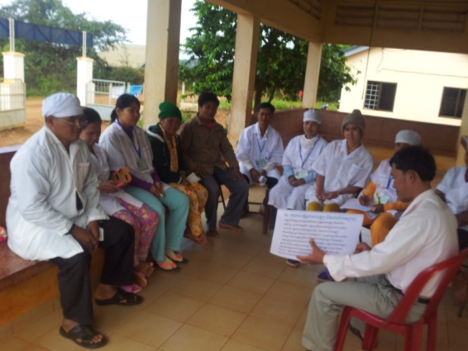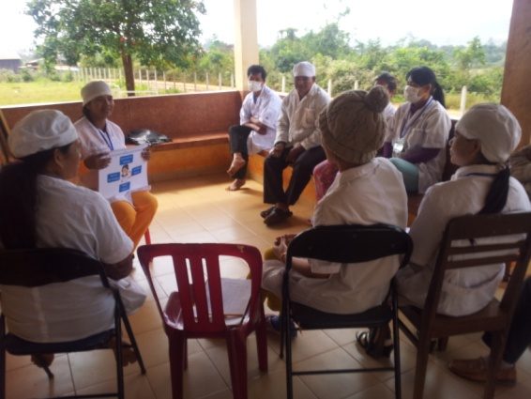
Fig.17 (Oral Health Education by Pichreada HC)
Fig.16 (Oral Health Education to Pichreada HC by Health Promotion Officer)

Made By: Mr. Meng Sokhalay
Project Coordinator
Date: 30th December 2013

